M.A.M. COLLEGE OF ENGINEERING & TECHNOLOGY

DEPARTMENT OF MECHANICAL ENGINEERING
ANNUAL DAY REPORT 2017-2018

MAM COLLEGE OF ENGINEERING AND TECHNOLOGY
DEPARTMENT OF MECHANICAL ENGINEERING
Annual report

1. INTERNSHIP AT VELMURUGAN INDUSTRIES
The following faculty members were underwent one month internship program at velmurugan industries, Thuvakudi , Trichy,
i)Mr.K.Dinesh
ii)Mr.R.Ravichandran
iii)Mr.J.Jayakumar
iv)Mr.R.Anandan
v)Mr.S.Raveendar

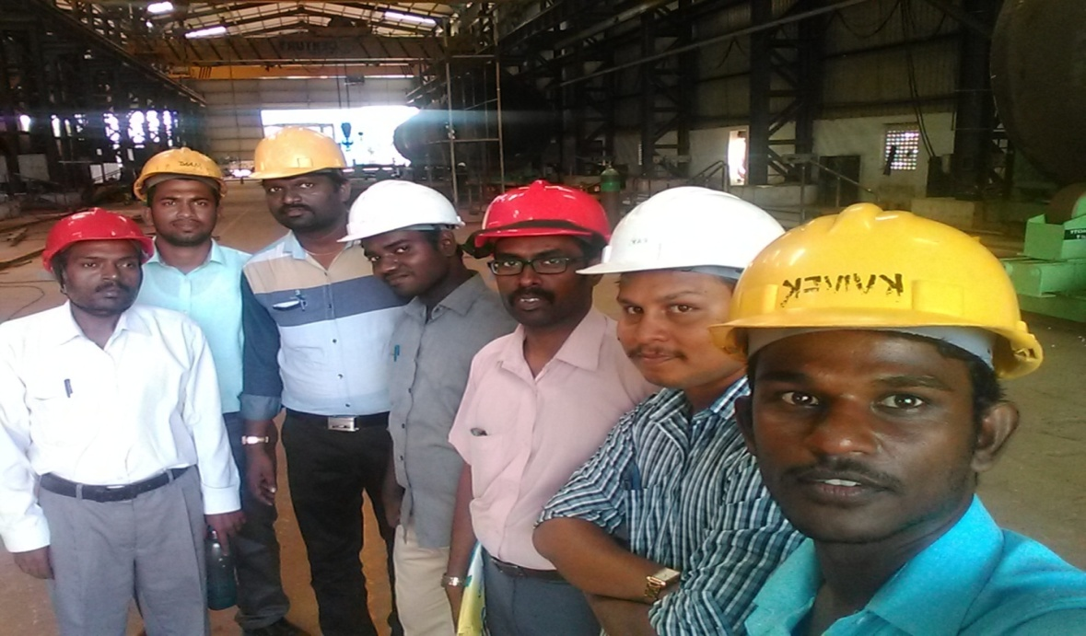

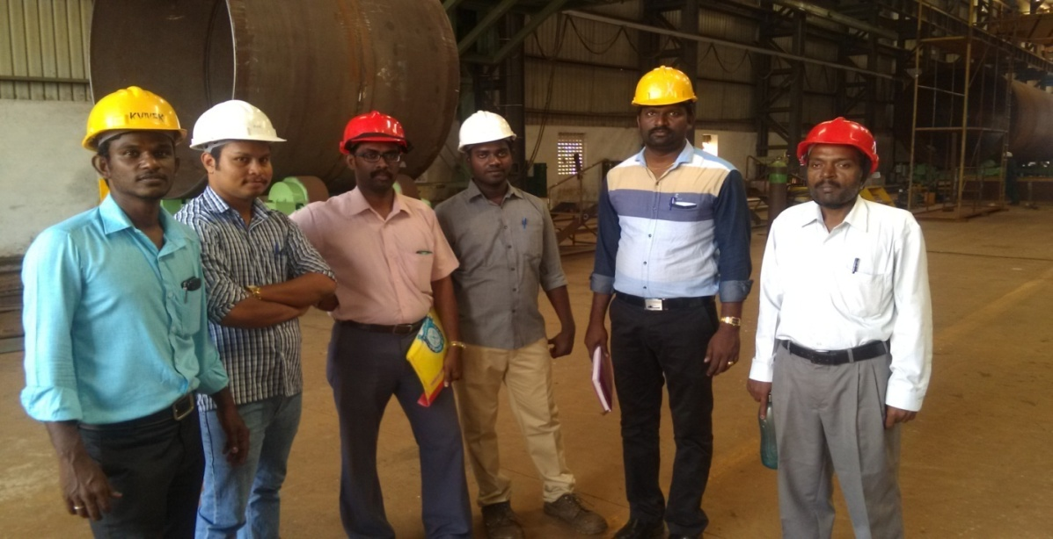

Industrial visit at velmurugan industries Dr. P. Selvaraj, K. Vijayan, Rajiv Gandhi and S.Raveendar

2. INDUSTRIAL VISIT AT POWER GEAR LTD

As a part of PALS activity, our faculty members Mr.C.Sasidharan and Mr.A.Mohan kumar had visited “Power Gear Ltd” at Tambaram, Chennai on 24.11.2017.
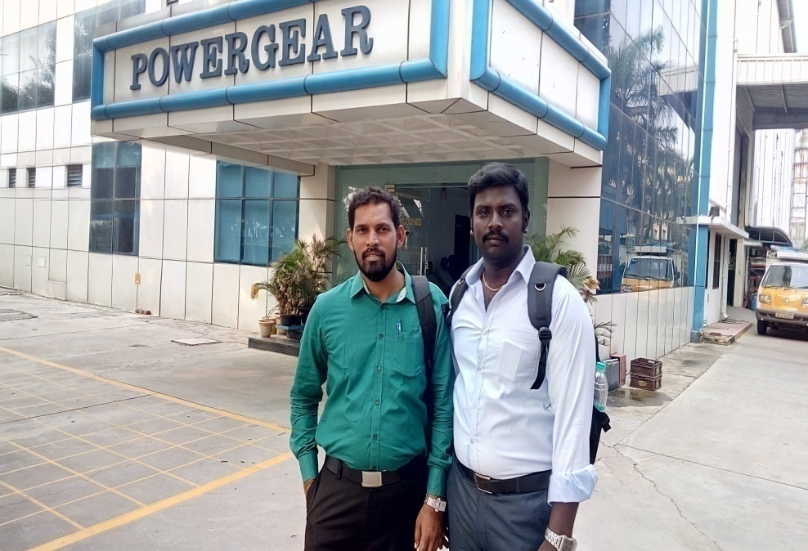

3. INDUSTRIAL VISIT AT ELGI
As a part of PALS activity, our faculty member MR. K. Inbasekaran visited ELGI industry at Coimbatore on 21.11.17

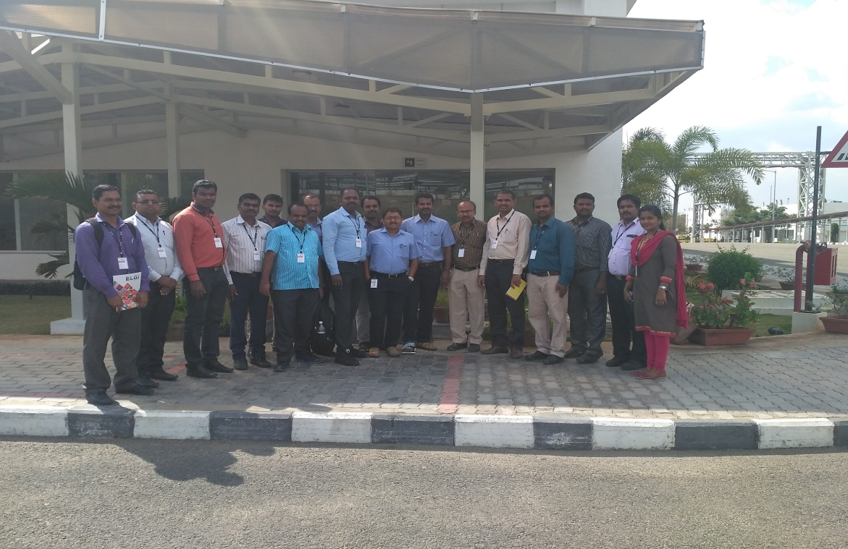

4. INDUSTRIAL VISIT AT MAHINDRA RESEARCH VALLEY

As a part of PALS, activity,our faculty members Mr.K.Vijayan and Mr.P.Maheswaran were visited Mahindra Research Valley on 5.12.2017 at Chennai.

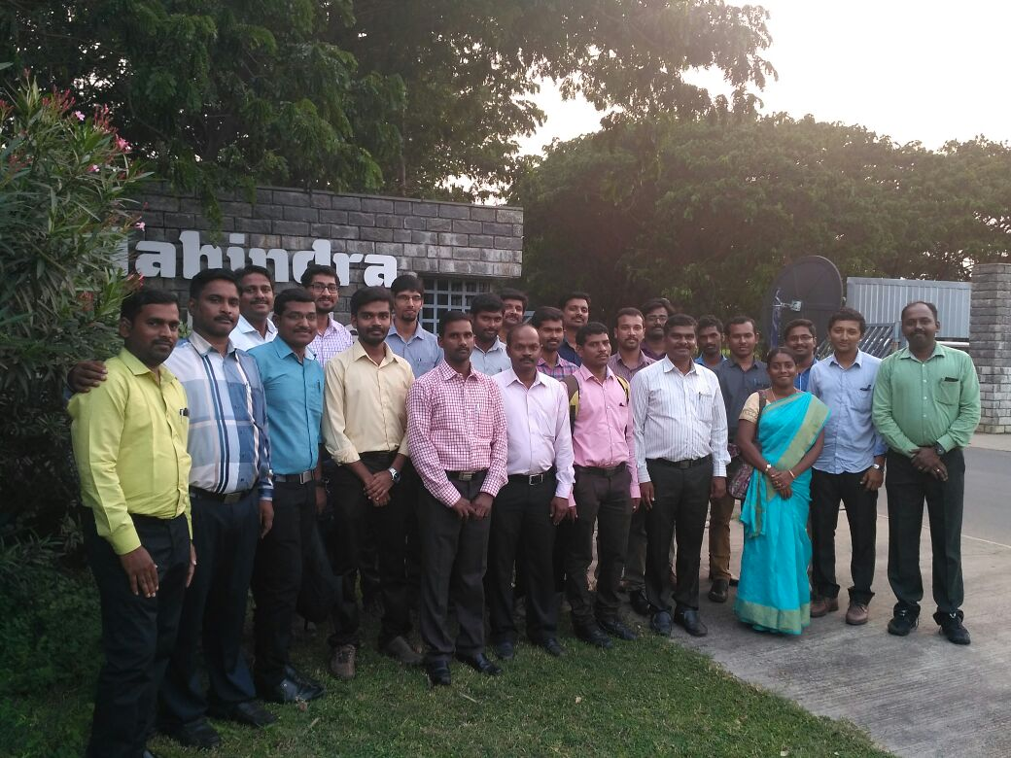

5. ONE DAY SEMINAR AT KSR COLLEGE
As a part of PALS activity Dr.P.Selvaraj, attended one day seminar at KSR engineering college on 18.10.2017

6. ONE DAY WORKSHOP AT SAIRAM ENGINEERING COLLEGE
Dr.P.Selvaraj attended one day workshop on e-governance systems organized by AICTE, at Sairam Engineering College, Chennai on17.11.2017

7. MAMCE Symposium
Dr. P. Selvaraj and Mr. P. Paventhan acted as a judge for national level symposium conducted in MAMCE

8. MAMSE Symposium
Dr. P. Selvaraj acted as a judge for national level symposium conducted in MAMSE

9. INTERNSHIP AT APEX HITECH
Our final year mechanical students were undergone one month internship at Apex hi-tech institute Bangalore.

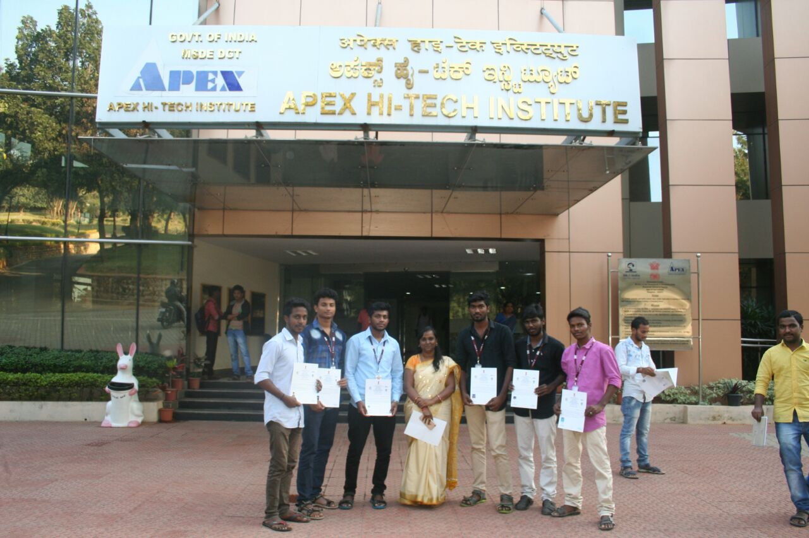

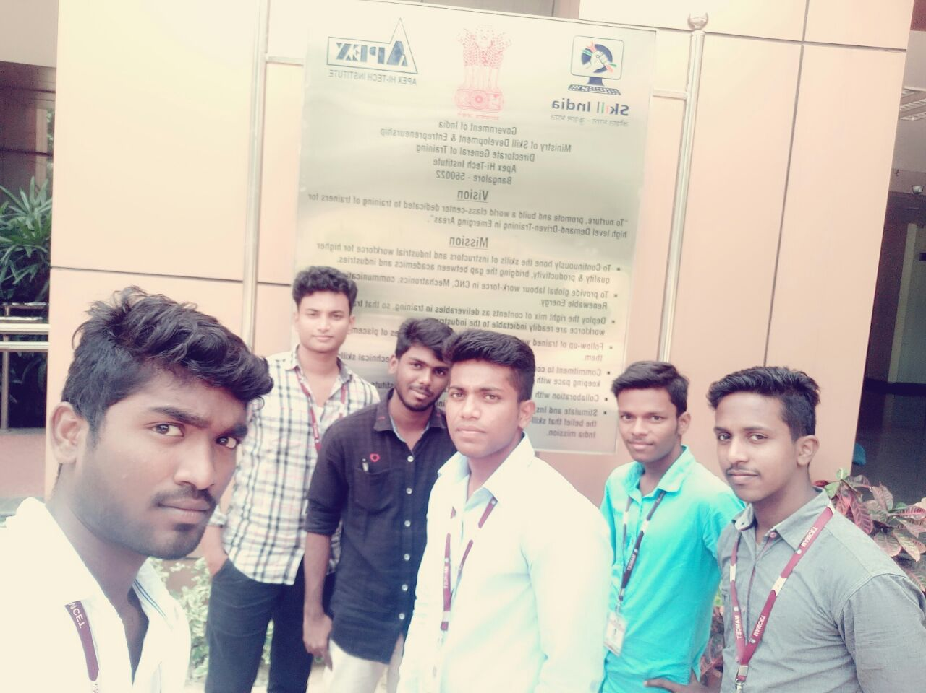

10. SEMINAR AT NIT TREC STEP
Our faculty members Dr.P.Selvaraj and Mr.A.Mohan kumar were attended one day seminar on the topic “INCUBATION” at NIT TREC STEP, Trichy.

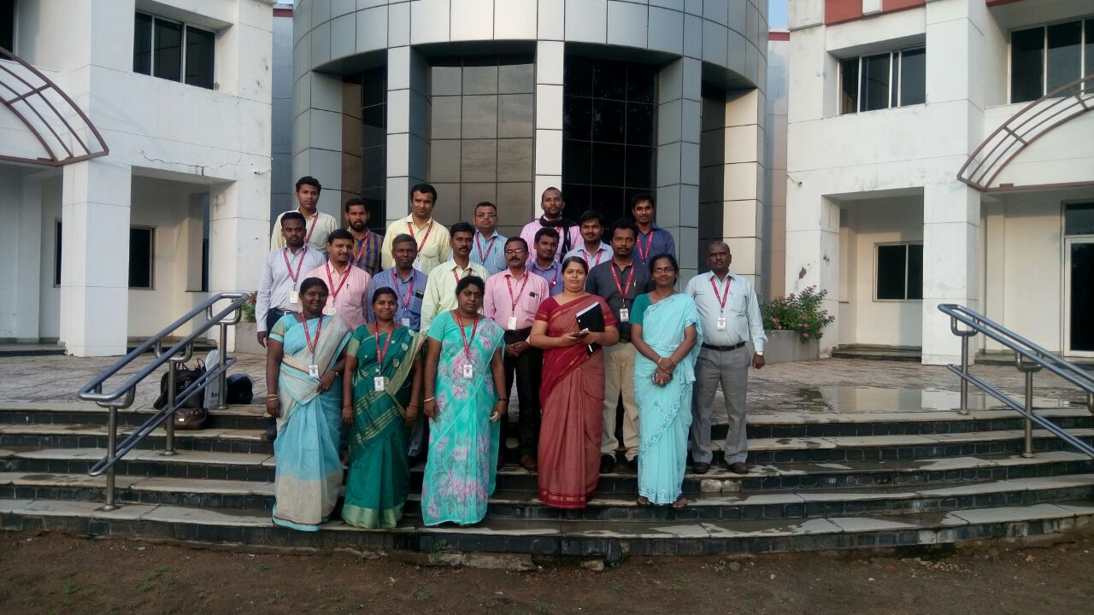

11. PROJECT WORKSHOP
Project workshop was organized by Dr.Selvaraj and Mr.C.Sasidharan for the mechanical engineering students on 23.11.17. to 25.11.17

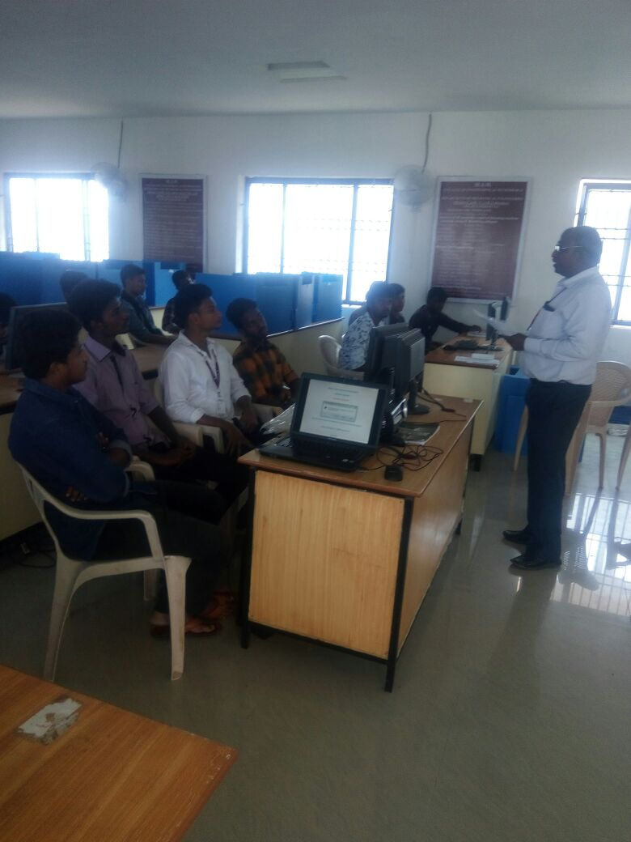

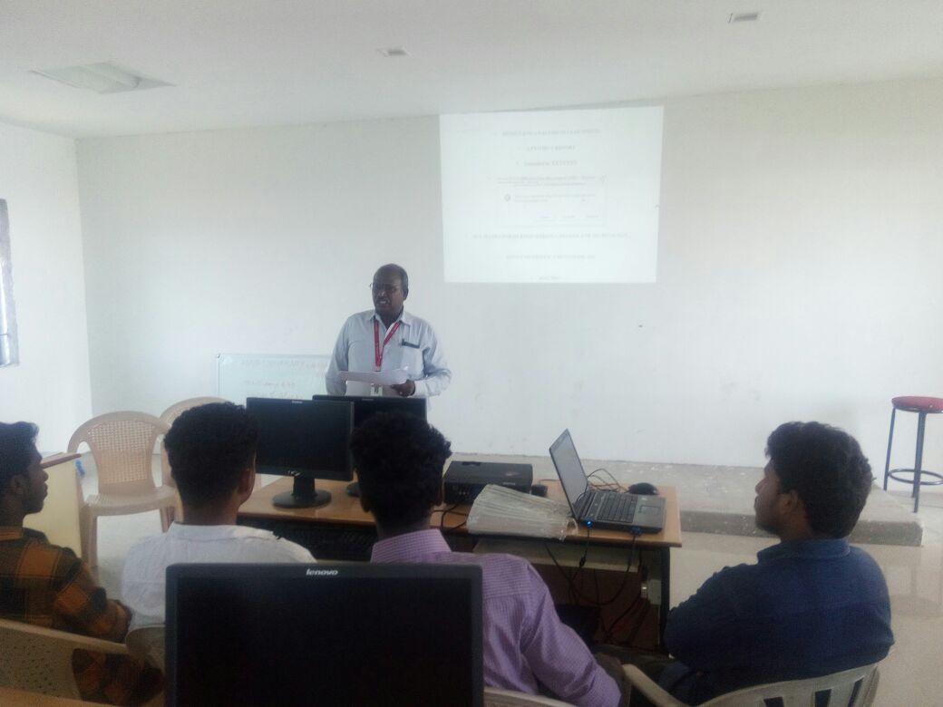

12. SYMPOSIUM AT ANNA UNIVERSITY PATTUKKOTTAI
Our department III yr students were participated various events in symposium, conducted by Anna University Pattukkottai.
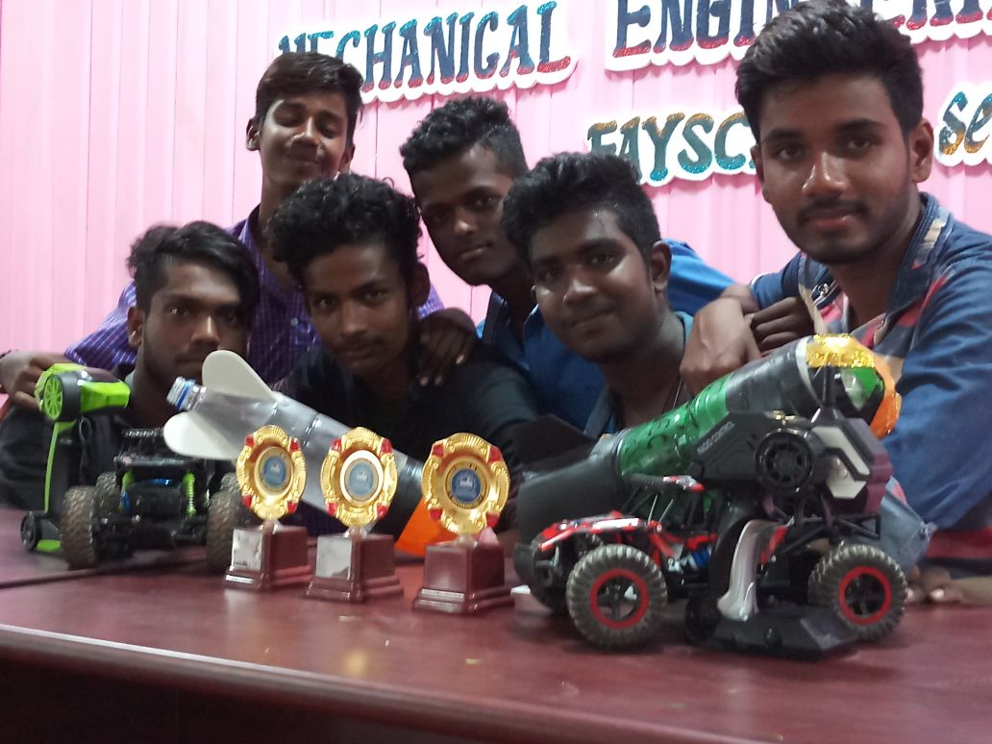

13. SYMPOSIUM AT KARPAGAM ENGINEERING COLLEGE:
The following III yr Mechanical students Mr.Izaz ahamed, Mr.Balaguru, Mrs. Dhivya Mutharasi,Mr.Manoj kumar, Mr.Arockiya Nelson Roy have participated in symposium held at Karpagam Engineering college on 2.2.2018 and won first prize in paper presentation and water rocketry event

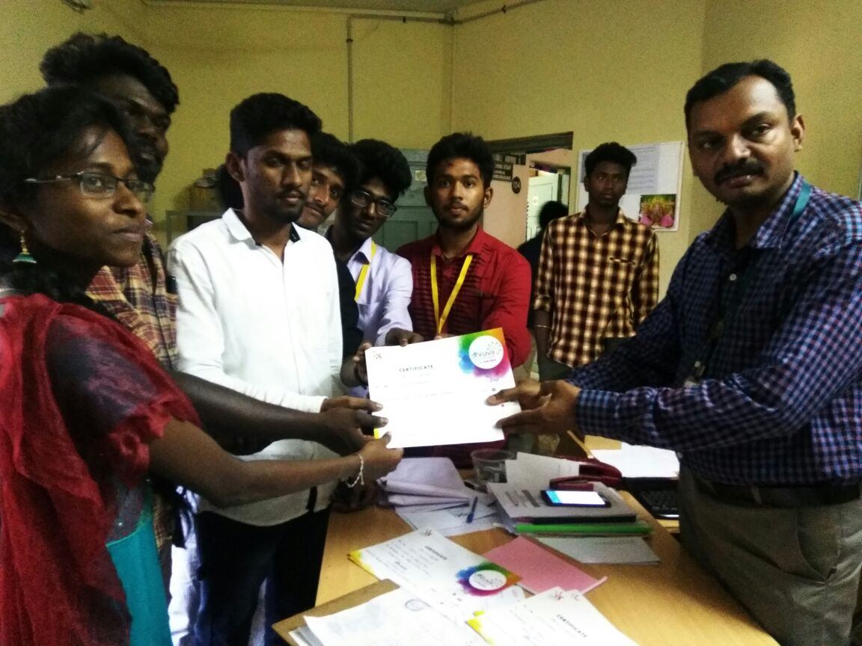

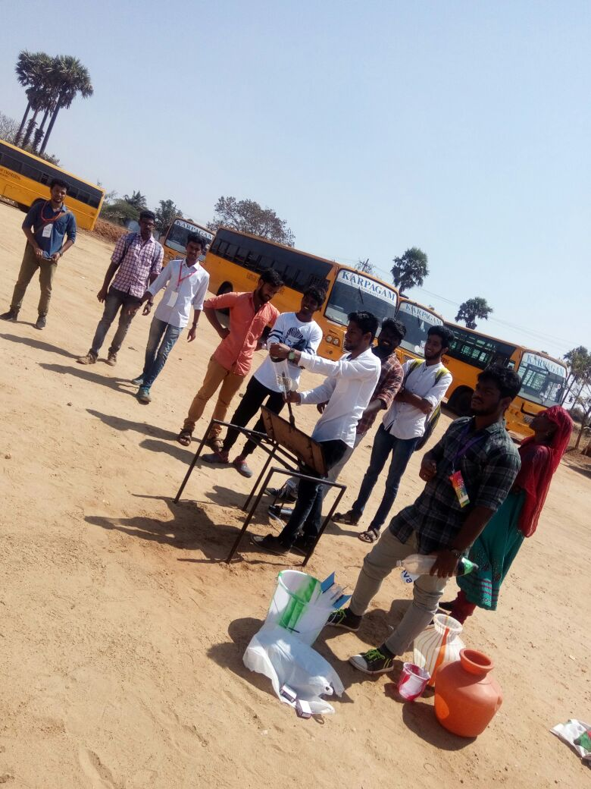

14. SEMINAR ON NDT
As a part of Skill Development Program two hour seminar has been conducted for III year & II year mechanical students on the topic Non Destructive Testing on 24.1.2018 by Aplus Trichy.

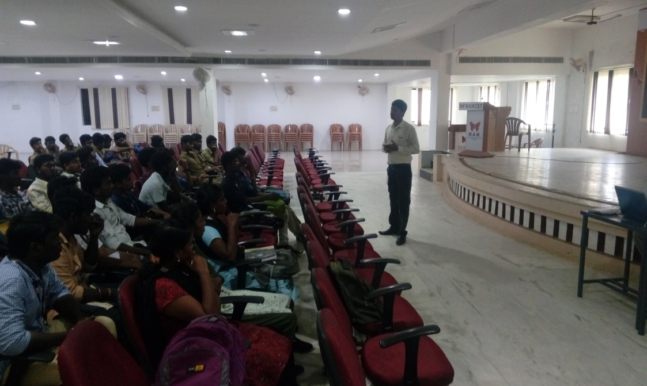

MECHANICAL STUDENT PLACED IN IDBI LIFE INSURANCE
Final year mechanical student Mr.Kishore Kumar got placed in IDBI Life insurance.

15. PALS T2P LECTURE:
OUR STUDENTS ATTENDED T2P LECTURE CLASS AT IIT CHENNAI ON 15.02.2018
WHICH IS CONDUCTED AS A STATE LEVEL PALS PROGRAMME
S.NO | NAME OF THE PARTICIPANTS | YEAR
1 | R. SARAVANAN | 3RD YEAR
2 | M. SUDHARSAN | 3RD YEAR
3 | K. SIVA | 3RD YEAR
4 | P. PRABU | 3RD YEAR
5 | S. MOHAMED RAFIUTHEEN | 3RD YEAR
6 | P. RAJESH KANNA | 3RD YEAR
7 | J. JERLIN | 3RD YEAR
8 | MOHAMMED SADIK | 2nd YEAR
9 | S. KALAI SELVAN | 3RD YEAR

16. PALS PROGRAMME AT JEYARAM COLLEGE OF ENGINEERING AND TECHNOLOGY:
OUR STUDENTS ATTENDED PALS PROGRAMME AT JEYARAM ENGINEERING COLLEGE;
THIS IS CONDUCTED AS A STATE LEVEL PROGRAMME ON 24.02.2018.
S.NO | NAME OF THE PARTICIPANTS | YEAR
1 | S.PRABU | 3RD YEAR
2 | R.VIKRAM | 3RD YEAR
3 | S.V. SUJIT | 3RD YEAR
4 | R. VIJAY | 3RD YEAR

17. WORKSHOP AT KARPAGAM COLLEGE OF ENGINEERING:(01.02.2018)
S.NO | NAME OF THE PARTICIPANT | YEAR
1 | R.SARAVANAN | 3RD YEAR
2 | M. RANJITH KUMAR | 3RD YEAR
3 | R. PRAKASH RAJ | 3RD YEAR
4 | E. PRAVEEN | 3RD YEAR
5 | S. MOHAMED HALIDH | 3RD YEAR

18. ENTREPRENURSHIP PROGRAMME (16.02.2018)
S.NO | NAME OF THE PARTICIPANTS | YEAR
1 | D.SANJAI | 3RD YEAR
2 | C.R. RAMANATHAN | 3RD YEAR

19. SYMPOSIUMS WON BY THIRD YEAR STUDENT CONDUCTED BY SUDHARSAN ENGG COLLEGE. FEB - 2018
S.NO | NAME OF THE PARTICIPANTS | YEAR
1 | S.EDWIN JEBAKUMAR | 3RD YEAR
2 | R.HARIHARASUDHAN | 3RD YEAR
3 | S.DEEPAK RAAJ | 3RD YEAR
4 | S.JEGAN KUTTIMANI | 3RD YEAR

20. PAPER PRESENTATION CONDUCTED BY NIT-TRICHY
S.NO | NAME OF THE EVENT | NAME OF THE PARTICIPANTS | YEAR
1. | CHUCK GLIDER | S.EDWIN JEBAKUMAR | 3RD YEAR
 |  | S.BALAGURU | 3RD YEAR
2. | ULTIMATE FIDGETER | S.JEGAN KUTTIMANI | 3RD YEAR
 |  | S.EDWIN JEBAKUMAR | 3RD YEAR
 |  | S.DEEPAK RAJ | 3RD YEAR
3. | NFS | S.EDWIN JEBAKUMAR | 3RD YEAR
 |  | L.JULIAN JOHNRAJ | 3RD YEAR
Our Students won 2nd place of overall performance titled as SYNERGY
21. PAPER PRESENTATION AND PROJECT EXPO CONDUCTED BY KARPAGAM UNIVERSITY
S.NO | NAME OF THE EVENT | NAME OF THE PARTICIPANTS | YEAR
1. | PAPER PRESENTATION | V.MANOJKUMAR | 3RD YEAR
 |  | S.AROKIYANELSON ROY | 3RD YEAR
 |  | S.IZAZ AHAMED | 3RD YEAR
2. | PROJECT EXPO  TEAM NAME- 3D HACKERS | V.MANOJKUMAR | 3RD YEAR
 |  | S.AROKIYANELSON ROY | 3RD YEAR
 |  | S.IZAZ AHAMED | 3RD YEAR
 |  | S.ASSOUR RAHMAN | 3RD YEAR
 |  | M.MOHAMED ABDUL BASHITH | 3RD YEAR
 |  | A.IMRANKHAN | 3RD YEAR
 |  | S.GOWTHAMAN | 3RD YEAR
 |  | S.BALAGURU | 3RD YEAR
 |  | R.PRAKASHRAJ | 3RD YEAR
 |  | S.V.SUJITH | 3RD YEAR
 |  | MOHAMES FAZIL | 3RD YEAR
 |  | G.LAKSHMI NARAYANAN | 3RD YEAR
 |  | C.JAYARAMAN | 3RD YEAR
 |  | MURALI | 3RD YEAR
3. | WATER ROCKTERY | S.AROKIYANELSON ROY(1ST PRIZE) | 3RD YEAR
 |  | S.ASSOUR RAHMAN(1ST PRIZE) | 3RD YEAR
 |  | A.IMRANKHAN(1ST PRIZE) | 3RD YEAR
 |  | S.BALAGURU(2ND PRIZE) | 3RD YEAR
 |  | M.MOHAMED ABDUL BASHITH(2ND PRIZE) | 3RD YEAR
 |  | DIVYA MUTHARASI(2ND PRIZE) | 3RD YEAR

22. PAPER PRESENTATION AND TECHNICAL QUIZ CONDUCTED BY KINGS COLLEGE OF ENGINEERING ON FEB 9 2018.
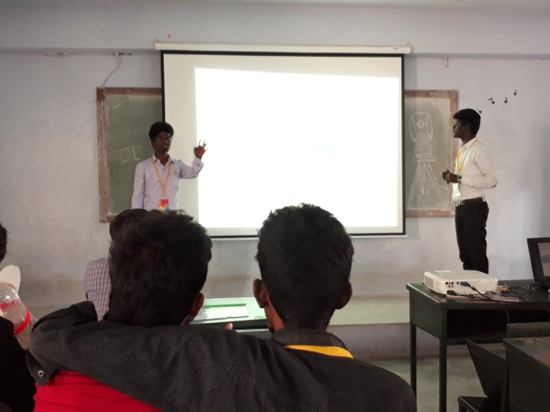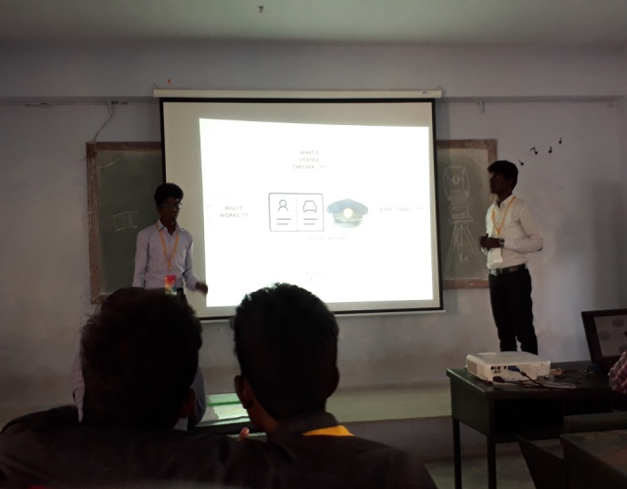
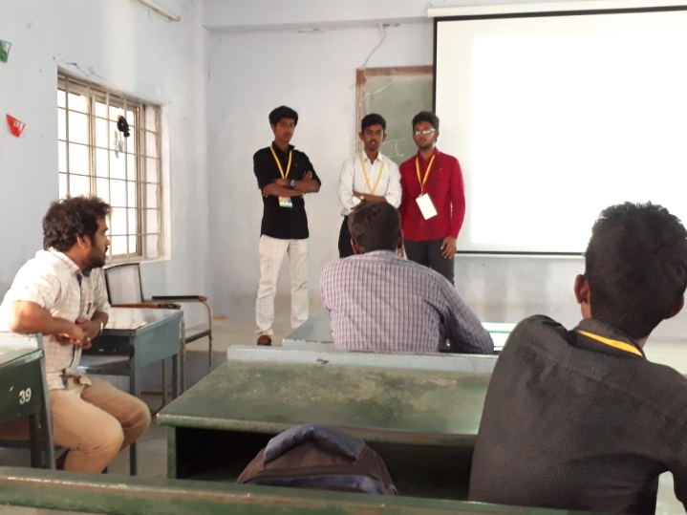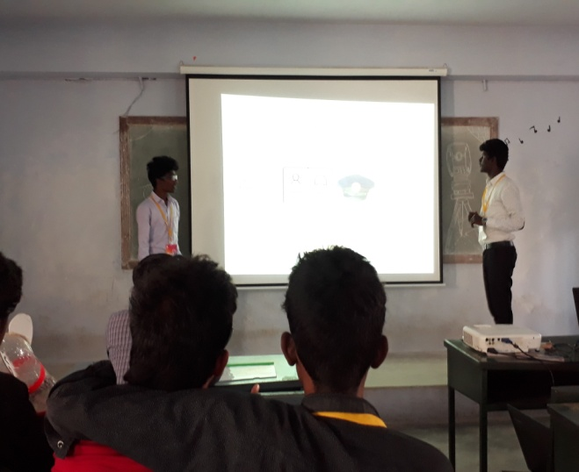
S.NO | NAME OF THE EVENT | NAME OF THE PARTICIPANTS | YEAR
1. | PAPER PRESENTATION | V.MANOJKUMAR(2ND PRIZE) | 3RD YEAR
 |  | S.AROKIYANELSON ROY(2ND PRIZE) | 3RD YEAR
 |  | S.IZAZ AHAMED(2ND PRIZE) | 3RD YEAR
2. | TECHNICAL QUIZ | A.IMRANKHAN(1ST PRIZE) | 3RD YEAR
 |  | S.BALAGURU(1ST PRIZE) | 3RD YEAR
 |  | M.MOHAMED ABDUL BASHITH(1ST PRIZE) | 3RD YEAR

23. SKIT CONDUCTED BY KONGU COLLEGE OF ENGINEERING ON FEB 8 2018.
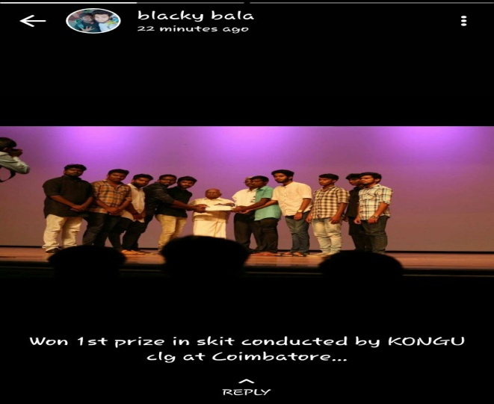
S.NO | NAME OF THE EVENT | NAME OF THE PARTICIPANTS | YEAR
1. | SKIT | S.ASSOUR RAHMAN | 3RD YEAR
 |  | S.BALAGURU | 3RD YEAR
 |  | A.IMRANKHAN | 3RD YEAR
 |  | S.GOWTHAMAN | 3RD YEAR
 |  | R.PRAKASHRAJ | 3RD YEAR
 |  | S.HARHARA SUDHAN | 3RD YEAR
 |  | S.AKASH | 2ND YEAR
 |  | SALEETH FERNANDUS | 2ND YEAR
 |  | VIGNESH | 2ND YEAR

24. VARIOUS PROGRAMM CONDUCTED AT M.AM.S.E FEB 15 2018.
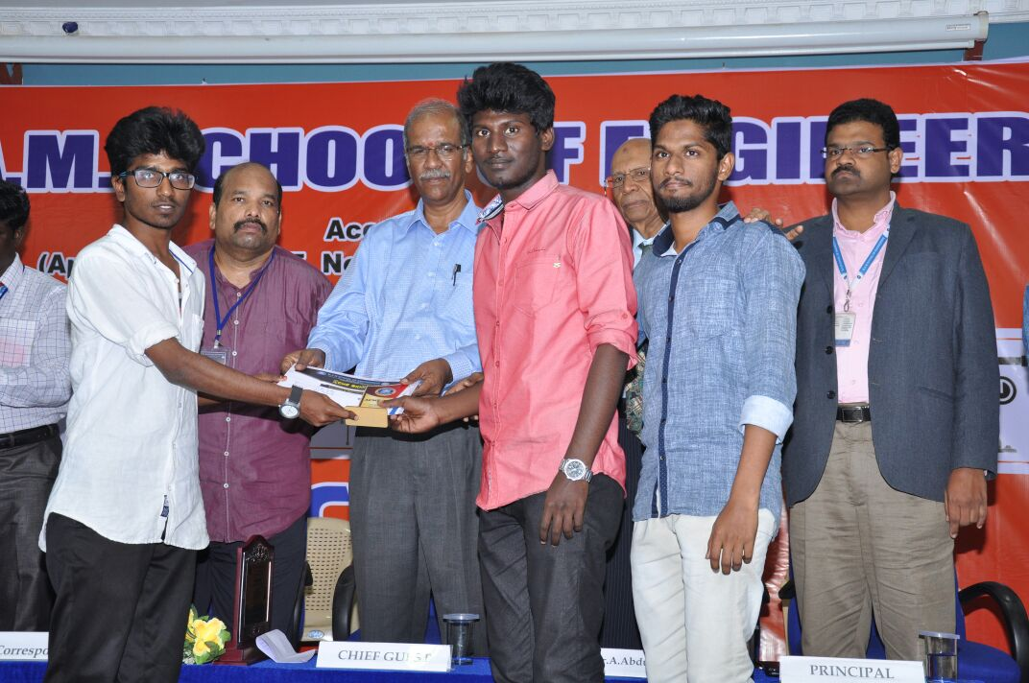
S.NO | NAME OF THE EVENT | NAME OF THE PARTICIPANTS | YEAR
1. | PAPER PRESENTATION | V.MANOJKUMAR(1ST PRIZE) | 3RD YEAR
 |  | S.AROKIYANELSON ROY(1ST PRIZE) | 3RD YEAR
 |  | S.IZAZ AHAMED(1ST PRIZE) | 3RD YEAR
2. | WATER ROCKTERY | V.MANOJKUMAR(1ST PRIZE) | 3RD YEAR
 |  | S.AROKIYANELSON ROY(1ST PRIZE) | 3RD YEAR
 |  | S.IZAZ AHAMED(1ST PRIZE) | 3RD YEAR
3. | NUTS AND BOLTS | S.AROKIYANELSON ROY(1ST PRIZE) | 3RD YEAR
 |  | M.MOHAMED ABDUL BASHITH(1ST PRIZE) | 3RD YEAR
4. | CONNECTIONS | S.ASSOUR RAHMAN(1ST PRIZE) | 3RD YEAR
 |  | S.BALAGURU(1ST PRIZE) | 3RD YEAR
 |  | A.IMRANKHAN(1ST PRIZE) | 3RD YEAR
 |  | S.AROKIYANELSON ROY(2ND PRIZE) | 3RD YEAR
 |  | S.IZAZ AHAMED(2ND PRIZE) | 3RD YEAR
 |  | S.GOWTHAMAN(2ND PRIZE) | 3RD YEAR

25. VARIOUS PROGRAMM CONDUCTED AT N I T TRICHY FEB 17&18 2018.
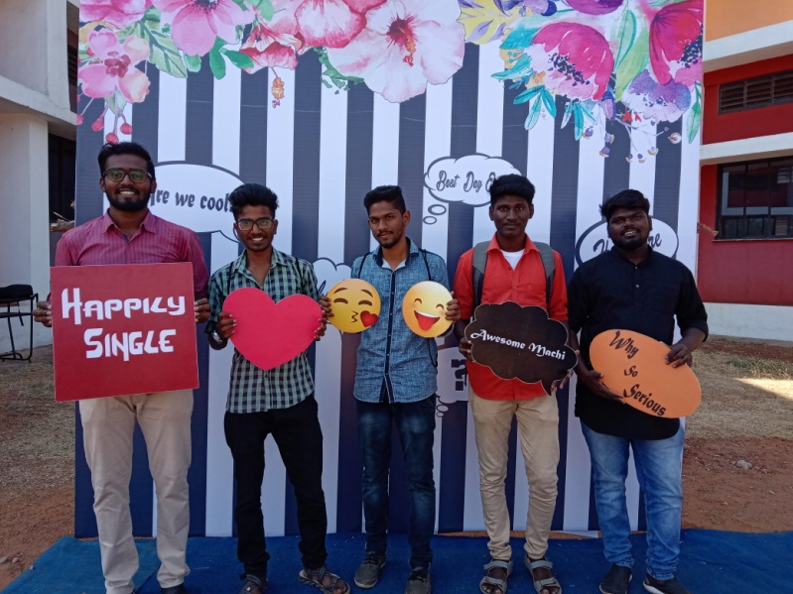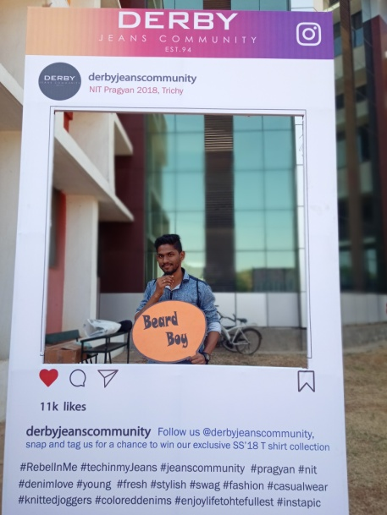

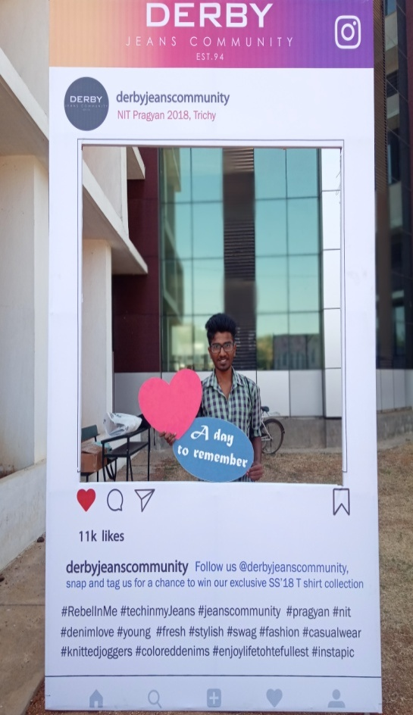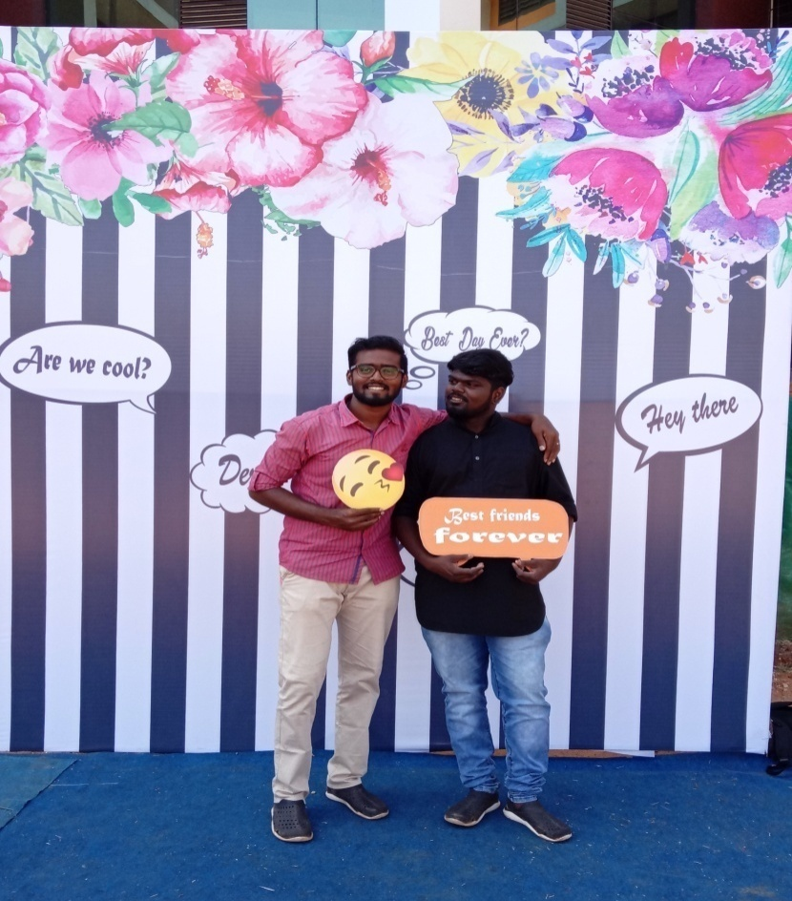

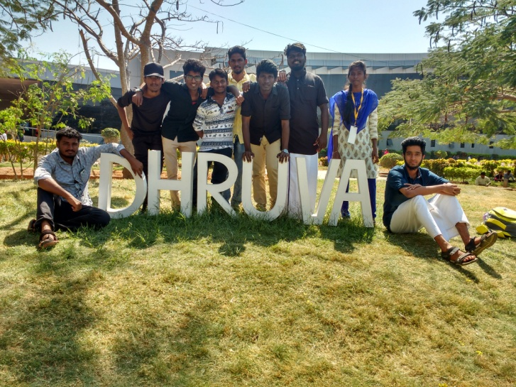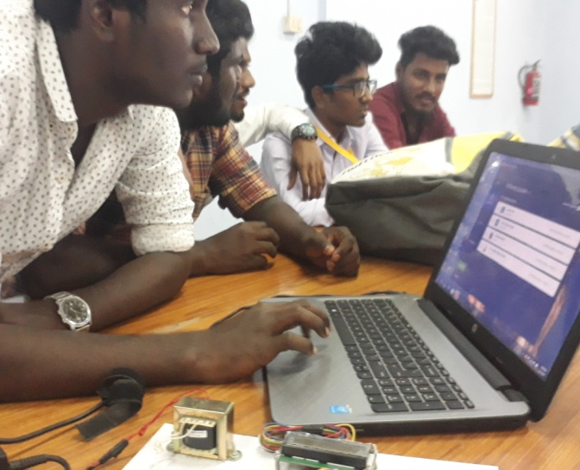
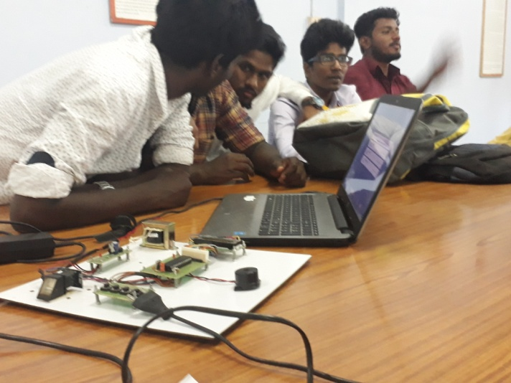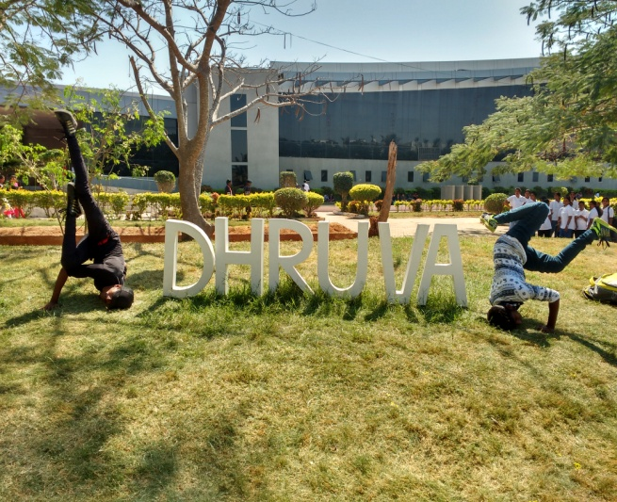
S.NO | NAME OF THE EVENT | NAME OF THE PARTICIPANTS | YEAR
1. | PAPER PRESENTATION | V.MANOJKUMAR(3RD PRIZE) | 3RD YEAR
 |  | S.AROKIYANELSON ROY(3RD PRIZE) | 3RD YEAR
 |  | S.IZAZ AHAMED(3RD PRIZE) | 3RD YEAR
2. | CHECK GLIDER | S.BALAGURU(1ST PRIZE) | 3RD YEAR
 |  | S.EDWIN JEBAKUMAR(1ST PRIZE) | 3RD YEAR
3. | ULTIMATE FIDGETTER | JEGAN KUTTIMANI(2ND PRIZE) | 3RD YEAR
 |  | R.PRAKASHRAJ(2ND PRIZE) | 3RD YEAR
 |  | S.EDWIN JEBAKUMAR(3RD PRIZE) | 3RD YEAR
 |  | S.DEEPAKRAJ(3RD PRIZE) | 3RD YEAR
4. | NFS | S.EDWIN JEBAKUMAR(3RD PRIZE) (1ST PRIZE) | 3RD YEAR
 |  | S.IZAZ AHAMED(2ND PRIZE) | 3RD YEAR
 |  | A.IMRANKHAN(3RD PRIZE) | 3RD YEAR

26. WATER ROCKETERY HELD AT SUDHARSAN ENGINEERING COLLEGE ON FEB-2018
S.NO | NAME OF THE EVENT | NAME OF THE PARTICIPANTS | YEAR
1. | WATER ROCKETERY | R.HARIHARASUDHAN(1ST PRIZE) | 3RD YEAR
 |  | S.EDWIN JEBAKUMAR(1ST PRIZE) | 3RD YEAR
 |  | JEGAN KUTTIMANI(2ND PRIZE) | 3RD YEAR
 |  | S.DEEPAKRAJ(3RD PRIZE) | 3RD YEAR

27. WATER ROCKETERY AND PAPER PERSENTATION HELD AT BUILDERS ENGINEERING COLLEGE ON2 1&22 FEB-2018
S.NO | NAME OF THE EVENT | NAME OF THE PARTICIPANTS | YEAR
1. | PAPER PRESENTATION | V.MANOJKUMAR(1ST PRIZE) | 3RD YEAR
 |  | S.AROKIYANELSON ROY(1ST PRIZE) | 3RD YEAR
 |  | S.IZAZ AHAMED(1ST PRIZE) | 3RD YEAR
2. | WATER ROCKTERY | S.IZAZ AHAMED(1ST PRIZE) | 3RD YEAR
 |  | S.BALAGURU(1ST PRIZE) | 3RD YEAR
 |  | M.MOHAMED ABDUL BASHITH(3RD PRIZE) | 3RD YEAR
 |  | S.ASSOUR RAHMAN(3RD PRIZE) | 3RD YEAR

28. VARIOUS PROGRAMM CONDUCTED AT HOLY CROSS COLLEGE TRICHY FEB 19 2018.
S.NO | NAME OF THE EVENT | NAME OF THE PARTICIPANTS | YEAR
1. | JUST A MINUTE | J.ALLAN JOY(1ST PRIZE) | 3RD YEAR
2. | FACIAL ART | S.GOPINATH(2ND PRIZE) | 3RD YEAR
 |  | S.BALAGURU(2ND PRIZE) | 3RD YEAR

29. POWER POINT PRESENTATION AT BISHOP HEBER COLLEGE TRICHY FEB 23 2018.

S.NO | NAME OF THE EVENT | NAME OF THE PARTICIPANTS | YEAR
1. | POWER POINT PRESENTATION | J.ALLAN JOY(3RD PRIZE) | 3RD YEAR
 |  | DANIEL (3RD PRIZE) | 2ND YEAR
 |  | SURENDHAR(3RD PRIZE) | 2ND YEAR

30. JUST IN TIME CONDUCTED AT MIET TRICHY FEB 24 2018.
S.NO | NAME OF THE EVENT | NAME OF THE PARTICIPANTS | YEAR
1. | JUST IN TIME | J.ALLAN JOY(2ND PRIZE) | 3RD YEAR
 |  | V.MANOJKUMAR(2ND PRIZE) | 3RD YEAR

31. INTERNSHIP PROGRAMME
S.NO | INSTITUTION | DATE | NAME OF THE PARTICIPANTS | YEAR
1. | K.R.FUELS(INTERNSHIP) | JAN 17-23 | S.IZAZ AHAMED | 3RD YEAR
 |  |  | S.EDWIN JEBAKUMAR | 3RD YEAR
 |  |  | DIVYA MUTHARASI | 3RD YEAR
 |  |  | DEVA | 3RD YEAR

32. WORKSHOP CONDUCTED ON NIT TRICHY ON FEB 16 2018
S.NO | NAME OF THE EVENT | NAME OF THE PARTICIPANTS | YEAR
1. | WORKSHOP(AUTOMOBILE) | DEVA | 3RD YEAR
2. | WORKSHOP(PHOTOGRAPHY) | S.ASSOUR RAHMAN | 3RD YEAR
 |  | S.BALAGURU | 3RD YEAR
 |  | S.ASSOUR RAHMAN | 3RD YEAR
 |  | M.MOHAMED ABDUL BASHITH | 3RD YEAR
 |  | V.MANOJKUMAR | 3RD YEAR
 |  | A.IMRANKHAN | 3RD YEAR

33. PALS CONDUCTED ON JAYARAM COLLEGE OF ENGINEERING THURAIYUR ON
FEB 19 2018
S.NO | NAME OF THE EVENT | NAME OF THE PARTICIPANTS | YEAR
1. | T2P LECTURER | S.KALAISELVAN | 3RD YEAR
 |  | L.JULEINJOHNRAJ | 3RD YEAR
 |  | K.ELAYARAJA | 3RD YEAR
 |  | K.MADHAN | 3RD YEAR
 |  | S.KAVIARASAN | 3RD YEAR

34. WORKSHOP CONDUCTED AT NATIONAL COLLEGE OF ARTS AND SCIENCE TRICHY ON FEB 19 2018
S.NO | NAME OF THE EVENT | NAME OF THE PARTICIPANTS | YEAR
1. | WORKSHOP | S.AROKIYANELSON ROY | 3RD YEAR
 |  | JEGAN KUTTIMANI | 3RD YEAR
 |  | S.IZAZ AHAMED | 3RD YEAR
 |  | DIVYA MUTHARASI | 3RD YEAR

35. PALS WORKSHOP CONDUCTED IIT CHENNAI ON FEB 15 2018
S.NO | NAME OF THE EVENT | NAME OF THE PARTICIPANTS | YEAR
1. | WORKSHOP | S.KALAISELVAN | 3RD YEAR

36. SPOKEN TUTORIAL
SPOKEN TUTORIAL -APRIL 2018
DEPARTMENT OF MECHANICAL ENGINEERING
S.NO | BATCH | DATE | TIME | NO OF STUDENTS REG | PRESENT | PASS
1 | 2014 | 11.4.2018 | 10:00 AM | 14 | 9 | 2
2 | 2015 |  | 2:00 PM | 37 | 21 | 15
3 | 2016 |  | 11:00 AM | 49 | 32 | 15
TOTAL |  |  |  | 100 | 62 | 32

36. NPTEL
Overall 36 candidates appeared in NPTEL exam for this current semester

37. PLACEMENT ACTIVITIES
S.NO | COMPANY NAME | PLACED STUDENTS
1 | IDBI | KISHORE KUMAR
2 | SUTHERLAND | SABARISH V.M
3 | SRI SAI PUMPS | CHINNARASU K
4 |  | DARVIN J
5 |  | DHINESH K
6 |  | PARTHIBAN B
7 |  | RAJAMOHAN E
8 |  | RAJITH B
9 |  | SABARISH V.M
10 |  | SYED RIZWAN N
11 |  | TAMILSELVAN E
12 |  | SRINIVASAN N
13 |  | VIGMESHWAREN D
14 | NCR CORPORATIONS - CHENNAI | PRABHU E
15 |  | ABDUL RAHUMAN A
16 |  | MOHAMED ASHIQ M
17 |  | HARISH KUMAR V
18 |  | SARAN M
19 |  | AZARUDEEN M.K
20 |  | MOHAMED FAZIL M
21 |  | RAVI KUMAR V
22 |  | KISHORE KUMAR
23 |  | AADHARSH
24 |  | VIGNESH R
25 |  | VIGNESH T
26 |  | SABARIDASAN
27 |  | HAVI DEVAN
28 |  | PRADEEP
29 | JBM | PREETH KUMAR

